# System description

## Flowchart

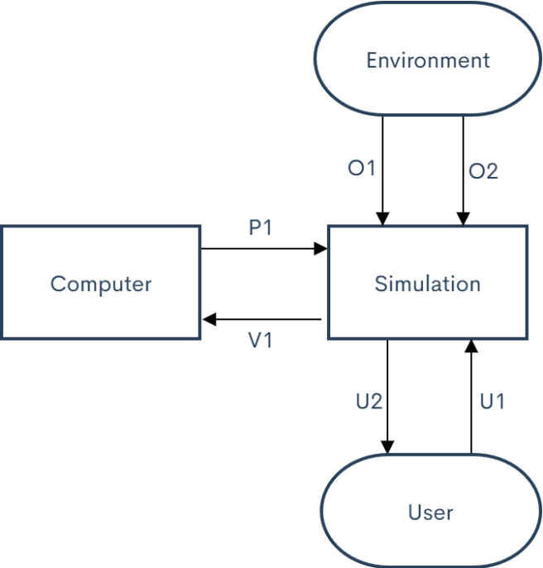

## Unique identifiers

|  |  |
| --- | --- |
| Unique ID | Long Name |
| U1 | User input |
| U2 | User output |
| P1 | Processing power |
| O1 | Environment impact temperature |
| O2 | Environment impact humidity |
| V1 | Calculated values |

## Table of limits

|  |  |  |  |  |
| --- | --- | --- | --- | --- |
| Interaction | Symbol | Min. | Max. | Unit |
| -> U1 | | | | |
| User input |  |  |  |  |
| Motor input rotation | $$n_{motor}$$ | 540 | 3300 | RPM |
| Motor input torque | $$T_{in}$$ | 5,4 | 33 | Nm |
| Propeller blade count | - | 2 | 6 | # |
| Propeller size (diameter) | $$d_{prop}$$ | 0,1 | 0,5 | m |
| Propeller torque | $$T_{prop}$$ | 5 | 30 | Nm |
| Propeller blade surface area | *Will not be considered in the design.* | | | |
| Propeller blade coefficient | $$µ_{blade}$$ | 0 | 1,2 | - |
| (Blade pitch) | | | | |
| Propeller pitch | - | 35 | 39 | ° |
| (Dalian MaritimeUniversity, 2018) | | | | |
| Propeller coefficient | $$K_{T}$$ | 0 | 0.4 |  |
|  | J | 0 | 0.9 |  |
| (SIMM Machinery Exhibition, 2019) | | | | |
| Shaft density | $$ρ$$ | $$7,7*{10}^{3}$$ | $$7,9*{10}^{3}$$ | $$kg/m^{3}$$ |
| Shaft size (diameter) | $$d_{shaft}$$ | $$10*{10}^{-3}$$ | $$50*{10}^{-3}$$ | m |
| Shaft length | $$l_{shaft}$$ | 0,25 | 1 | m |
| Shaft torsional stiffness | $$E$$ |  |  | Pa |
| (Hardness of general gears, 2017) | | | | |
| Gear material hardness | $$E$$ |  |  | Pa |
| Gear size (diameter) | $$d_{gear}$$ |  |  | m |
| (Standard gear tooth number, 2019) | | | | |
| Gear tooth number | - | 18 | 25 | # |
| Gear contact friction | $$F_{gear}$$ |  |  | N |
| Gear tooth shape |  |  |  |  |
| (Viscosity index) | | | | |
| Lubricant viscosity | $$η$$ | 5 | 30 | Pa*s |
| Bearing type | *Bearing types can be found in table (#).* | | | |
| Bearing inner diameter | $$d_{bear-in}$$ | $$10*{10}^{-3}$$ | $$50*{10}^{-3}$$ | m |
| Bearing outer diameter | $$d_{bear-out}$$ | $$20*{10}^{-3}$$ | $$100*{10}^{-3}$$ | m |
| Bearing friction | $$F_{bear}$$ |  |  | N |
| (Bearing friction coefficient, 2018) | | | | |
| Bearing friction coefficient | $$µ_{bear}$$ | $$0,8*{10}^{-3}$$ | $$2,5*{10}^{-3}$$ | - |
| U2 -> |  |  |  |  |
| User ouput |  |  |  |  |
| Thrust | $$T_{thrust}$$ | 9 | 550 | N |
| Total power loss | $$P_{loss}$$ | 5 | 30 | % of $P_{in}$ |
| -> P1 |  |  |  |  |
| Processing power |  |  |  |  |
|  |  |  |  | GHz |
|  |  |  |  |  |
| V1 -> |  |  |  |  |
|  |  | | | |
|  |  |  |  |  |
|  |  |  |  |  |
|  |  |  |  |  |
| -> O(#) -> |  |  |  |  |
| Environmental impacts | *Will not be considered in the design.* | | | |

# Reference

Bearing friction coefficient. (2018/6/27). source: https://wenku.baidu.com/view/3b7e69d133d4b14e852468ff.html

Blade pitch. (none date). source: wikipedia: https://en.wikipedia.org/wiki/Blade_pitch#cite_note-5

ExhibitionMachinerySIMM. (2019/4/29). Carbon steel density. source: https://wenku.baidu.com/view/53b97b2b326c1eb91a37f111f18583d048640f62.html

Hardness of general gears. (2017/9/20). source: https://zhidao.baidu.com/question/515963032.html

Standard gear tooth number. (2019/9/8). source: https://zhidao.baidu.com/question/162747752.html

UniversityMaritimeDalian. (2018/10/10). Open water Test. source: https://wenku.baidu.com/view/b248dd247ed5360cba1aa8114431b90d6d85896e.html

Viscosity index. (none date). source: wikipedia: https://en.wikipedia.org/wiki/Viscosity_index